Customer Shopping Behavior Analysis

1. Project Overview
This project analyzes customer shopping behavior using transactional data from 3,900 purchases across various product categories.
The goal is to uncover insights into spending patterns, customer segments, product preferences, and subscription behavior to guide strategic business decisions.
2. Dataset Summary
- Rows: 3,900
- Columns: 18
Key Features:
- Customer demographics:
  - Age, Gender, Location, Subscription Status
- Purchase details:
  - Item Purchased, Category, Purchase Amount, Season, Size, Color
- Shopping behavior:
  - Discount Applied, Promo Code Used, Previous Purchases, Frequency of Purchases, Review Rating, Shipping Type
- Missing Data:
  - 37 values missing in the Review Rating column
3. Exploratory Data Analysis using Python
Steps Followed:
• Data Loading
Imported the dataset using pandas.
• Initial Exploration
Used:
- df.info() to check structure
- df.describe() for summary statistics
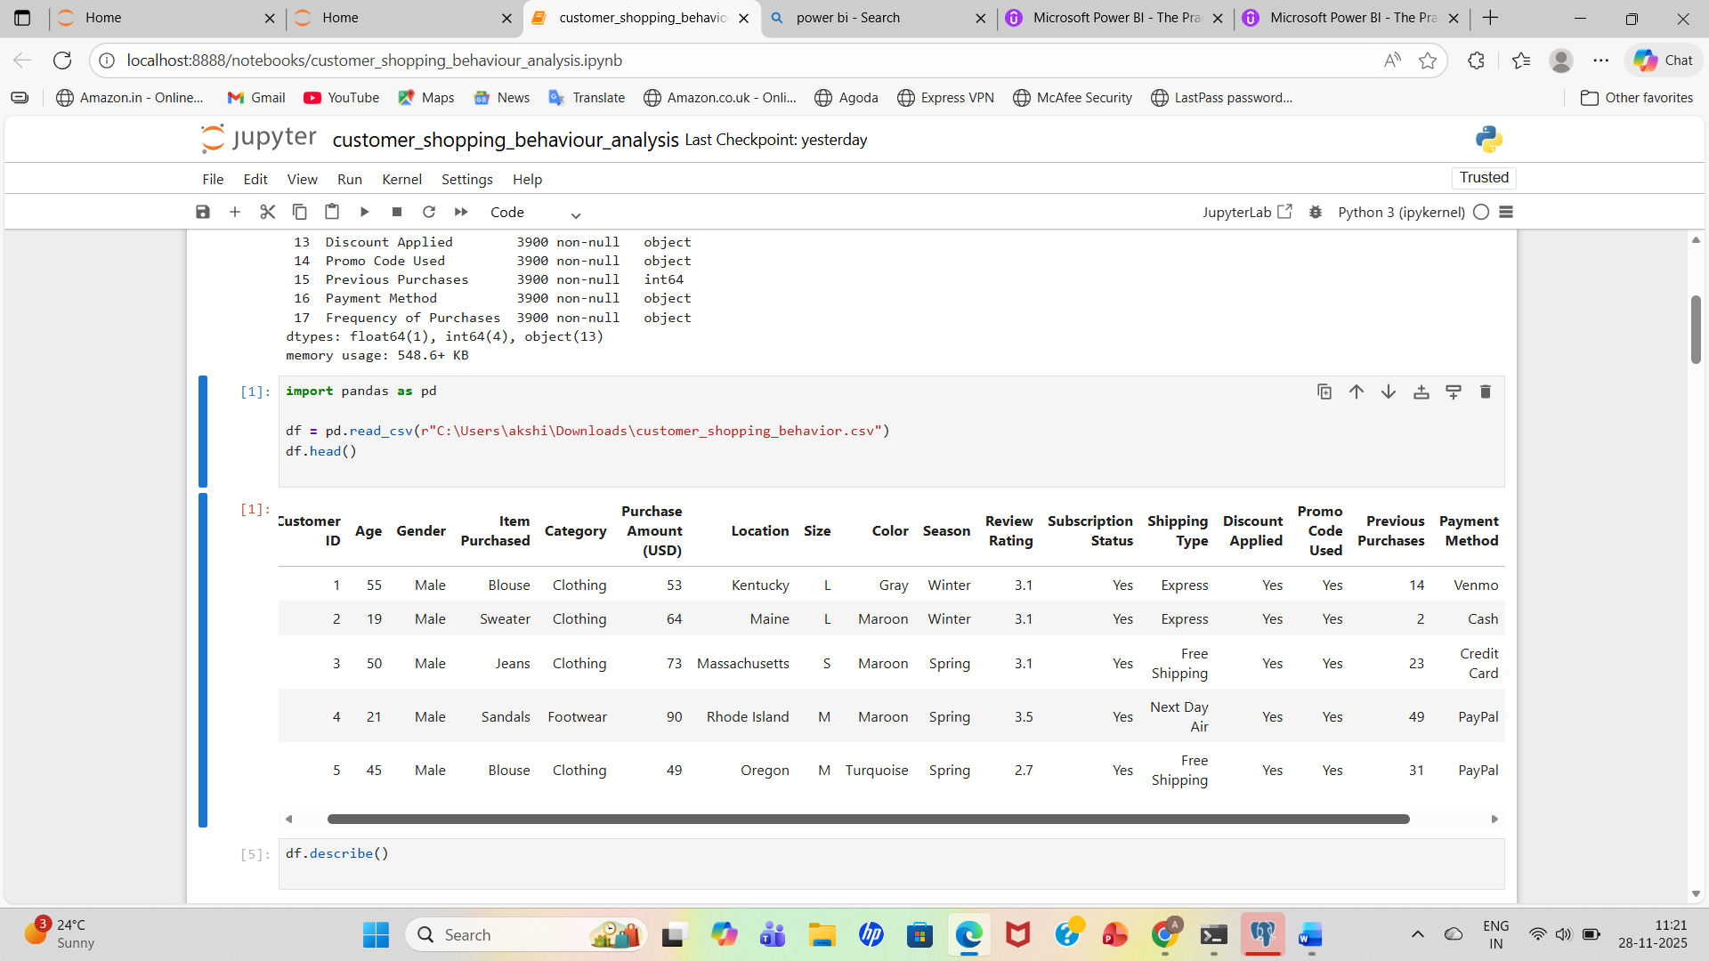

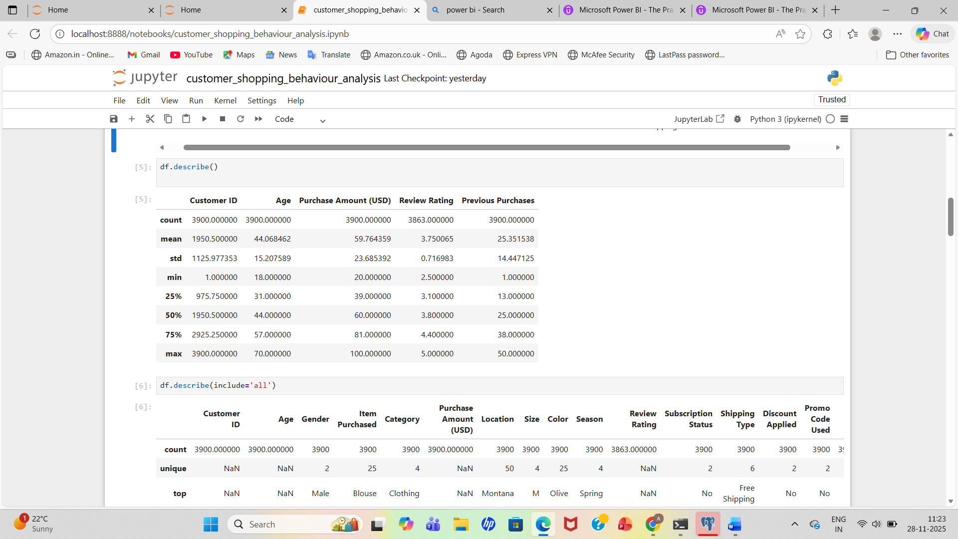
• Missing Data Handling
- Checked for null values
- Imputed missing values in the Review Rating column using the median rating for each product category
• Column Standardization
- Renamed all columns to snake_case for better readability and documentation.
• Feature Engineering
- Created age_group column by binning customer ages
- Created purchase_frequency_days column from purchase data
• Data Consistency Check
- Verified if discount_applied and promo_code_used were redundant
Dropped promo_code_used
• Database Integration
- Connected Python script to PostgreSQL
- Loaded the cleaned DataFrame into the SQL database for analysis.
4. SQL Analysis & Key Insights
we performed structured analysis in PostgreSQL to answer key business questions:
1. Revenue by Gender
Compared total revenue generated by male vs. female customers.
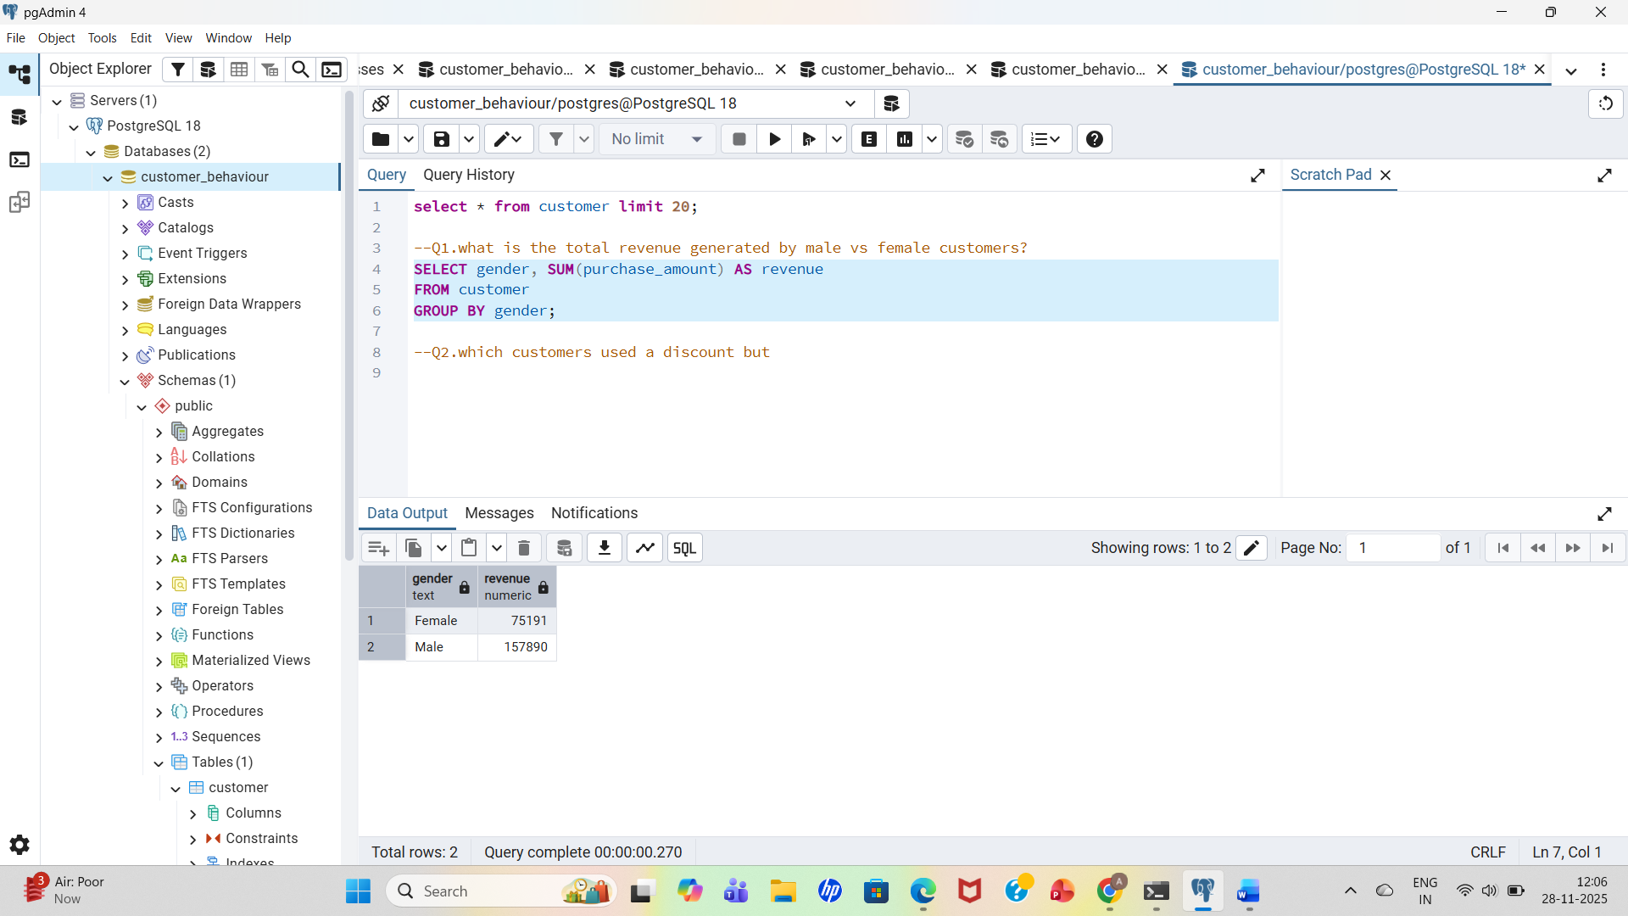
Result:
- Female: 75,191
- Male: 157,890
2. High-Spending Discount Users
Identified customers who:
- Used discounts
- Still spent above the average purchase amount.
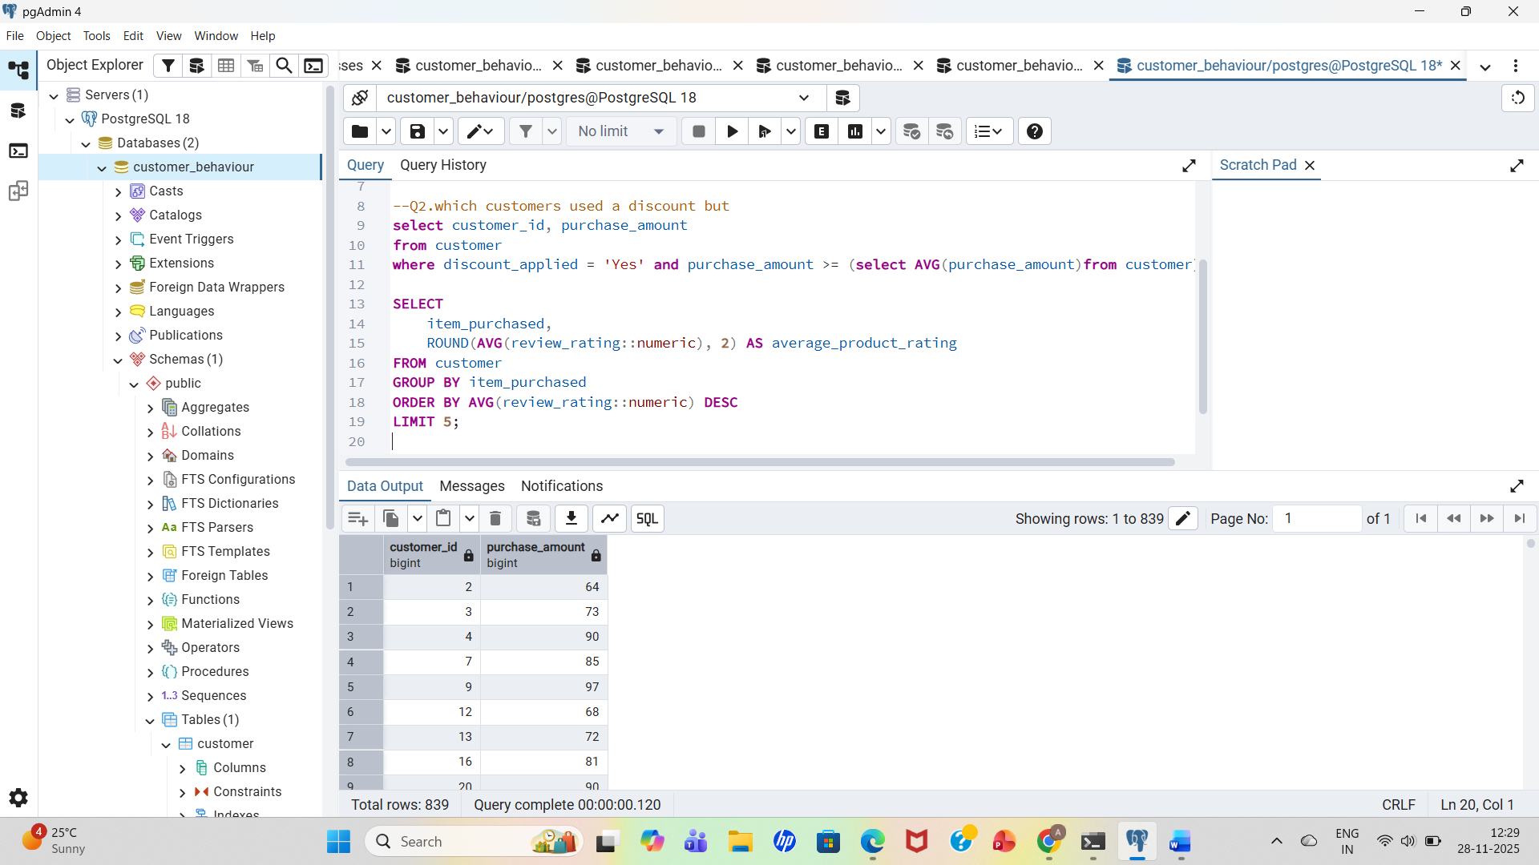
3. Top 5 products rating
Found products with the highest average review ratings.
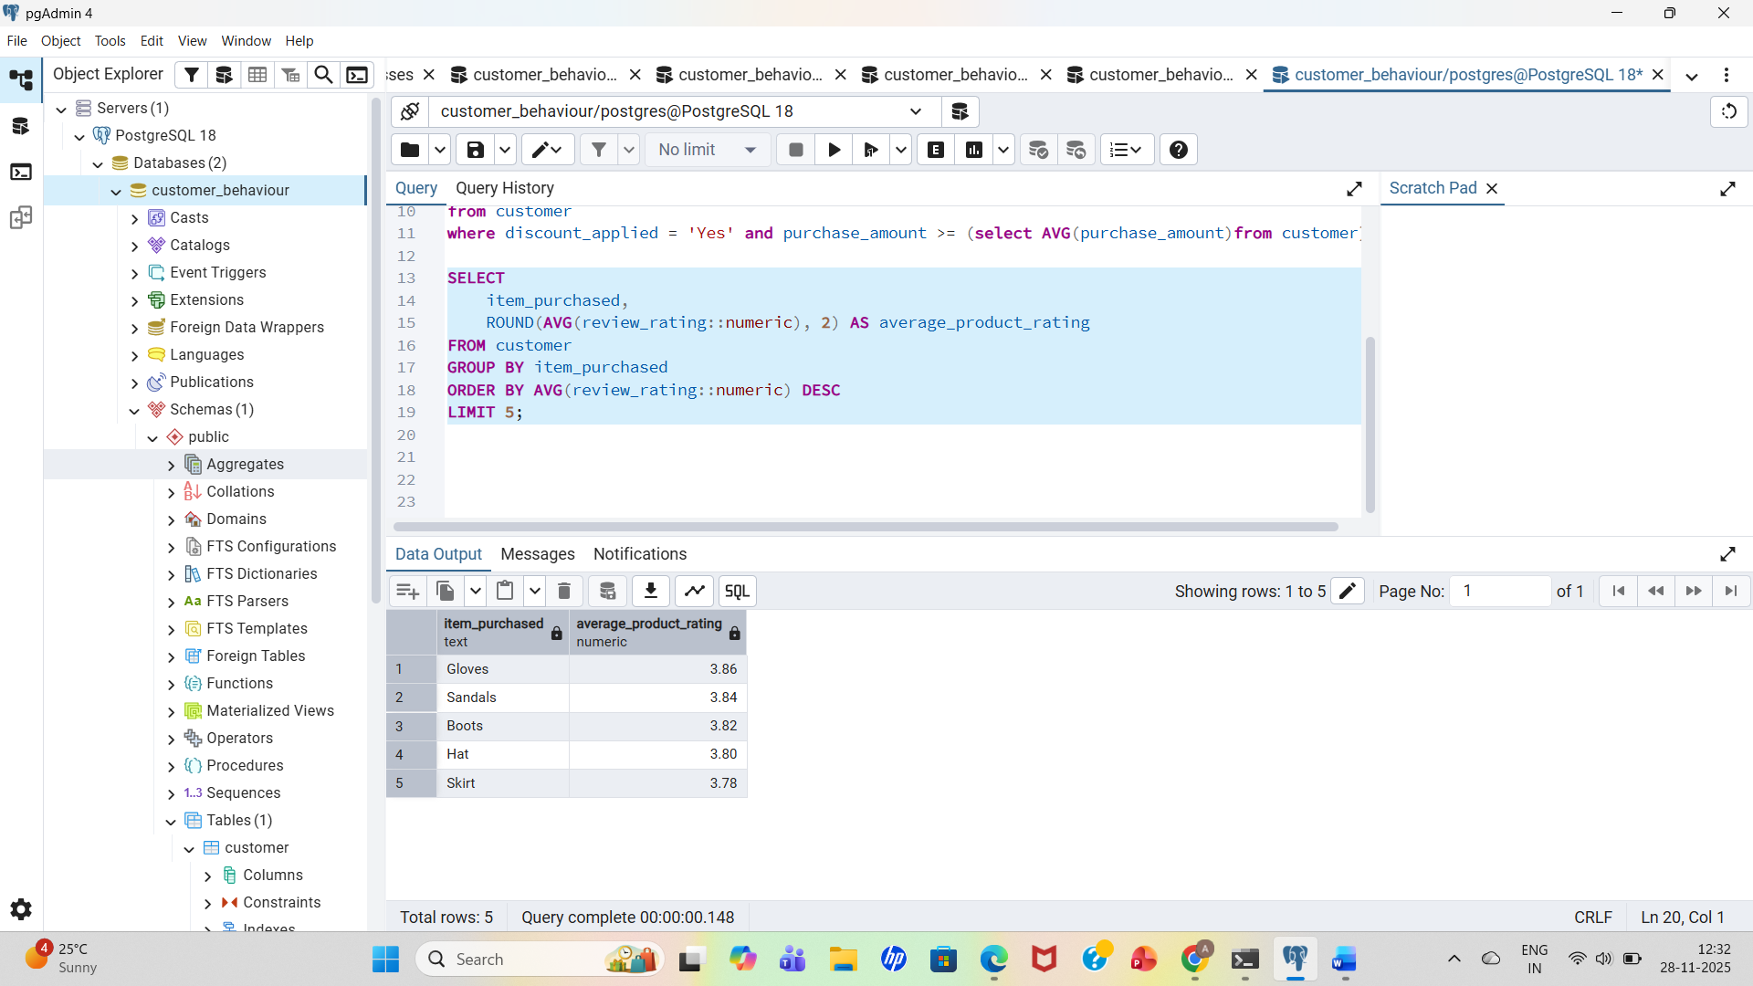
4.Shipping Type Comparison
compared average purchase amounts between amounts between standard and express shipping.
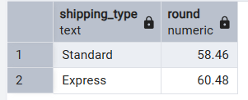
5. Subscription Status Impact
Compared spending of subscribed vs. non-subscribed customers.
average spend and total revenue across supscription status.

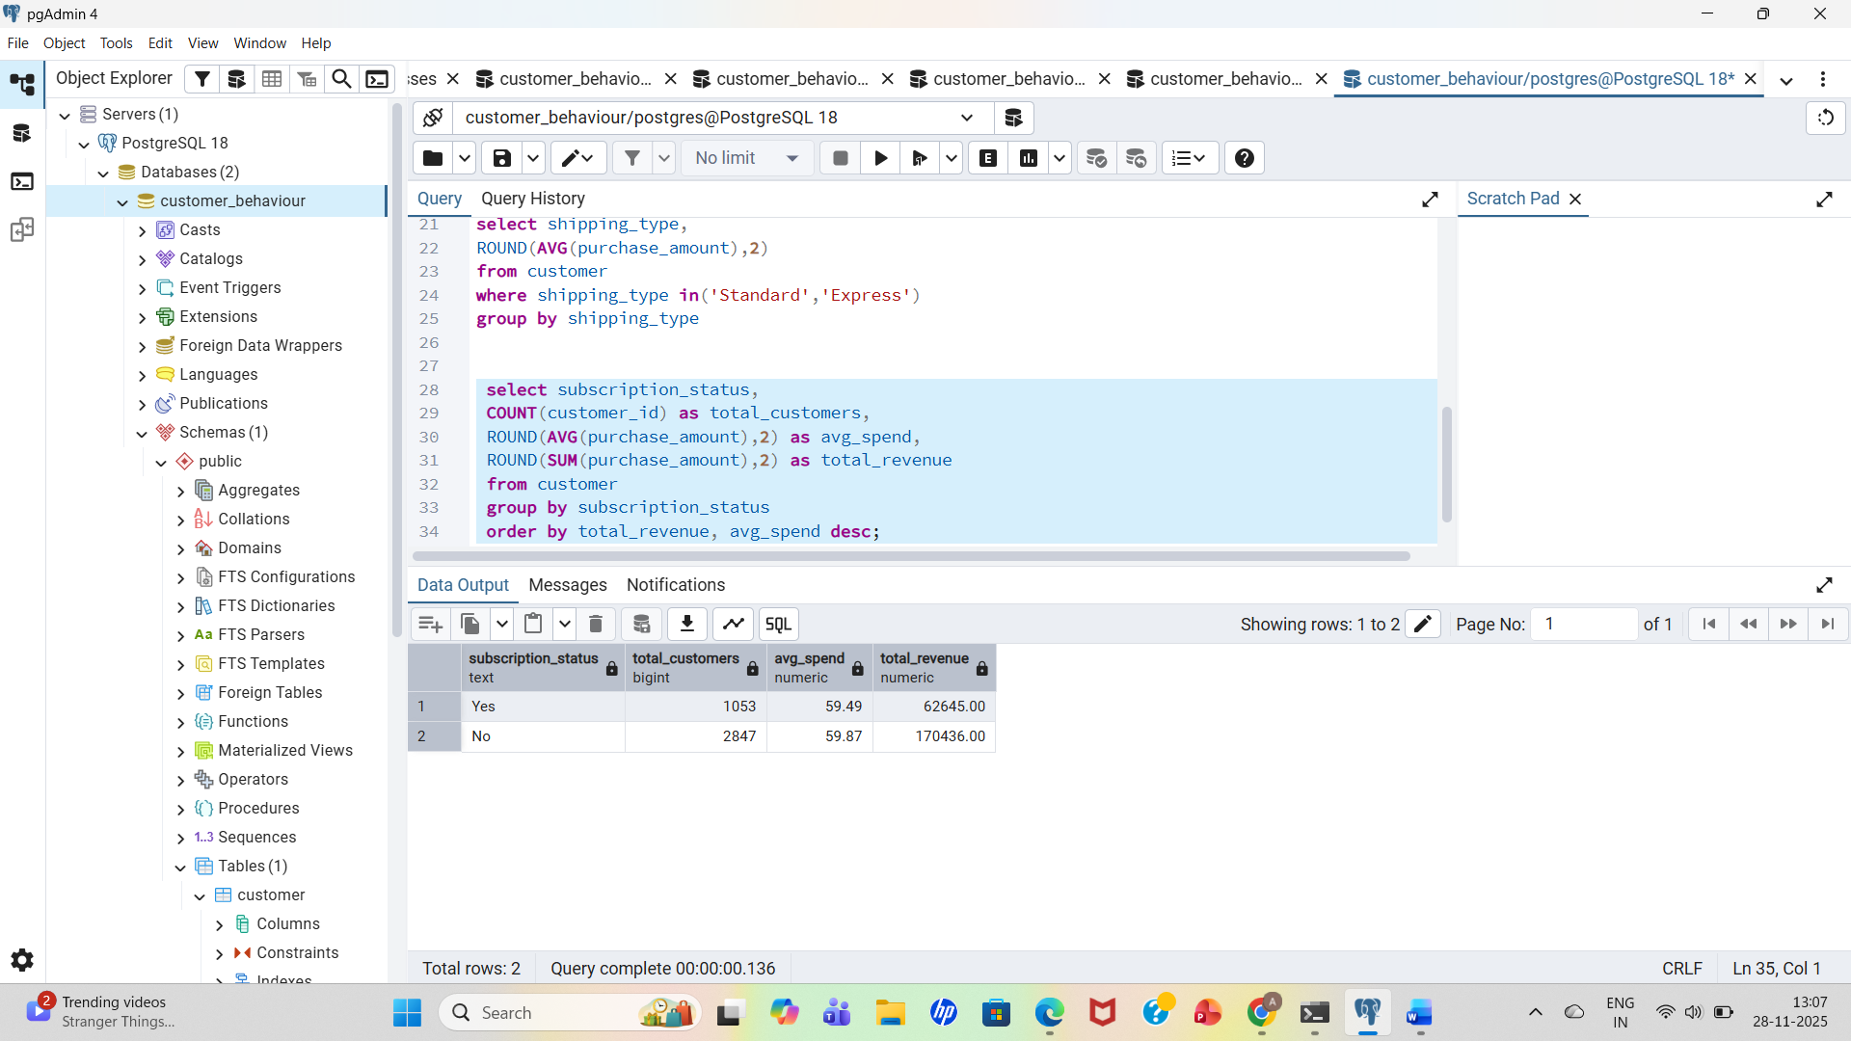
6.Discount-Dependent Products
Identified 5 products with the highest percentage of discounted purchases. 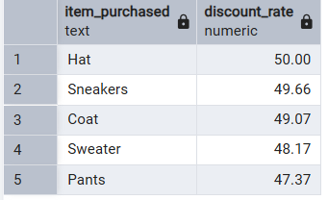
7.Customer Segmentation
Classified customers into New,Returning, and Loyal segments based on purchase history .
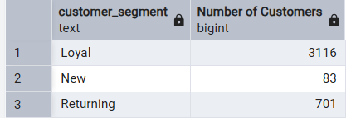
8.Top 3 Products Category
listed the most purchased within each category
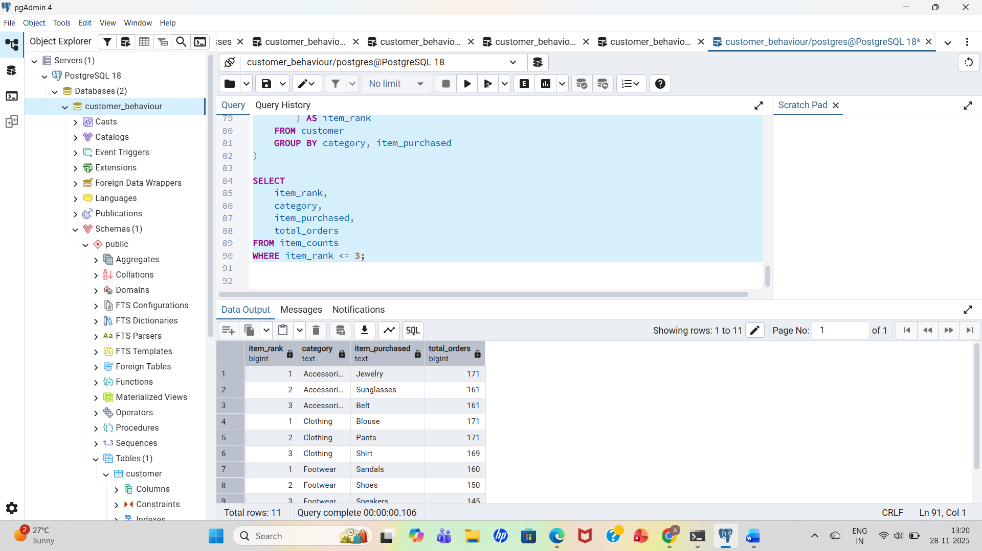
9.Repeat Buyers and Subscriptions
checked whether customers with >5 purchases are more likely to subscribe.
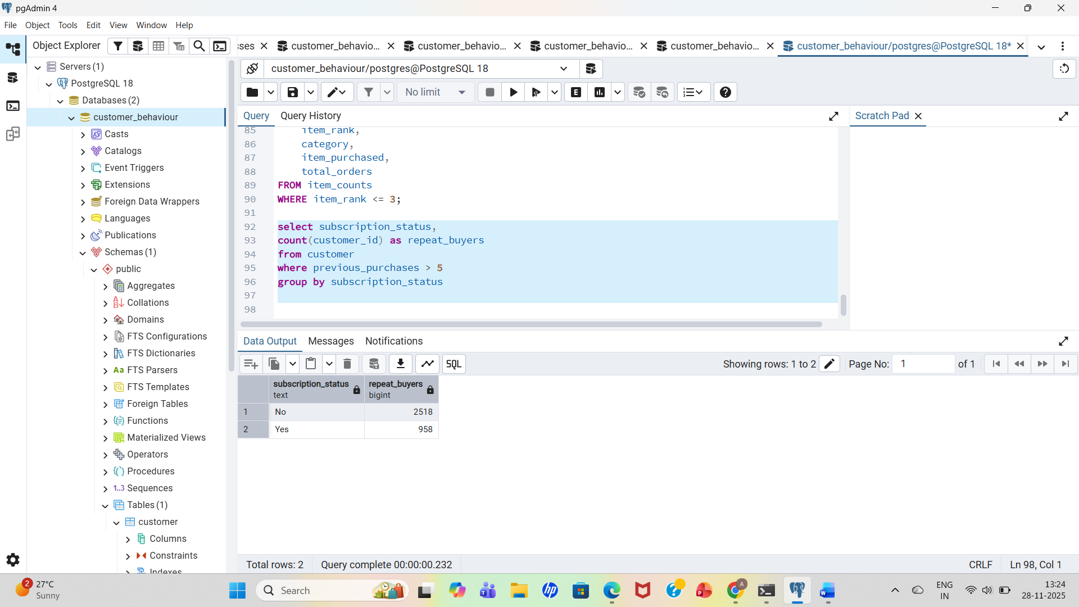
10. Revenue by Age Group
Calculated total revenue contribution of each age group.
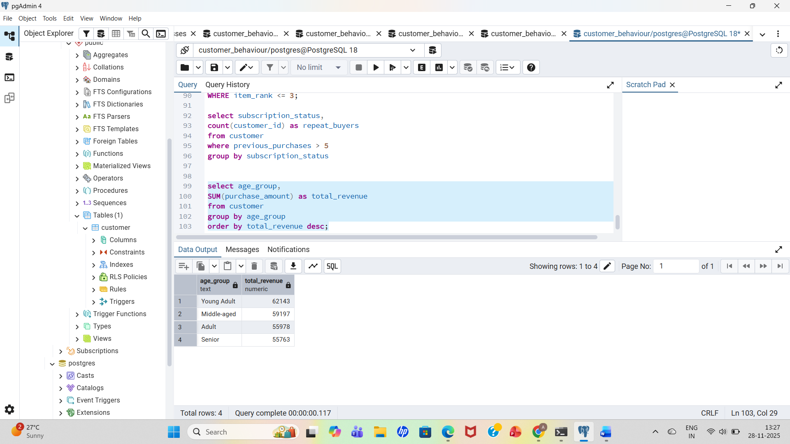
5. Power BI Dashboard Highlights
The interactive dashboard visualizes:
- Total Customers: 3.9K
- Average Purchase Amount: $59.76
- Average Review Rating: 3.75
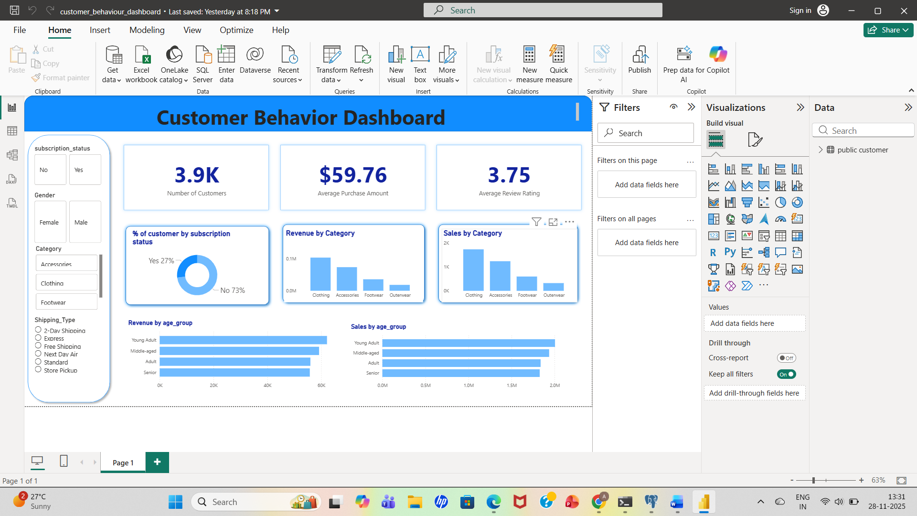
Key Visuals:
- % of customers by subscription status
- Revenue by category
- Sales by category
- Sales by age group
- Filters for gender, category, shipping type, location, etc.
6.Business Recommendations
- Boost Subscriptions – Promote exclusive benefits for subscribers.
- Customer Loyalty Programs – Reward repeat buyers to move them into the “Loyal” segment.
- Review Discount Policy – Balance sales boosts with margin control.
- Product Positioning – Highlight top-rated and best-selling products in campaigns. Targeted Marketing – Focus efforts on high-revenue age groups and express-shipping customers

